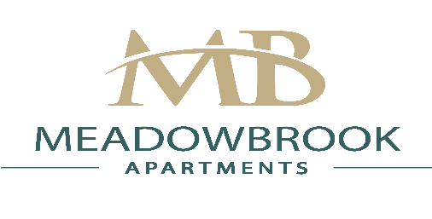

5314 Whetstone Rd. Phone: (804) 275-1740
North Chesterfield, VA. 23234 Fax: (804) 271-3293
www.meadowbrookapts.org Leasing@meadowbrookapts.org

Dear Prospective Resident(s),

Thank you for your interest in Meadowbrook Apartments. In order to apply for an apartment home,
please complete the entire application form, print and sign the rental verification form & send it in to our office with:

1. $40.00 application fee per adult payable by money order ONLY.

2. $100.00 reservation fee payable by money order ONLY (this fee will be applied toward the security
deposit once the application is fully approved by management)

*Note: Application Fee and Reservation fee must be on separate money orders*

3. A copy of your 2 most recent pay stubs or an offer letter of employment if employed with your current company for less than 30 days. If your job requires payment in the form of “tips” then we will need a letter on letter head from your company with an estimated average of tips collected per month accompanied with your 2 most recent pay stubs.

We look forward to meeting you and having the opportunity to meet all of your apartment needs.
Please feel free to call our office with any questions.

Thank you,

Meadowbrook Apartments Leasing Team
804-275-1740

